Question: Analyze the political effects of WWII during the Cold War period, focusing on at least two countries.

Document 1:
To ensure the peaceful development of nations, free from coercion, the United States has taken a leading part in establishing the United Nations, The United Nations is designed to make possible lasting freedom and independence for all its members. We shall not realize our objectives, however, unless we are willing to help free peoples to maintain their free institutions and their national integrity against aggressive movements that seek to impose upon them totalitarian regimes. This is no more than a frank recognition that totalitarian regimes imposed on free peoples, by direct or indirect aggression, undermine the foundations of international peace and hence the security of the United States.
The peoples of a number of countries of the world have recently had totalitarian regimes forced upon them against their will. The Government of the United States has made frequent protests against coercion and intimidation, in violation of the Yalta agreement, in Poland, Rumania, and Bulgaria. I must also state that in a number of other countries there have been similar developments.
At the present moment in world history nearly every nation must choose between alternative ways of life. The choice is too often not a free one. Excerpt from the Truman Doctrine 1947
Document 2:
Aside from the demoralizing effect on the world at large and the possibilities of disturbances arising as a result of the desperation of the people concerned, the consequences to the economy of the United States should be apparent to all. It is logical that the United States should do whatever it is able to do to assist in the return of normal economic health in the world, without which there can be no political stability and no assured peace. Our policy is directed not against any country or doctrine but against hunger, poverty, desperation, and chaos. Its purpose should be the revival of a working economy in the world so as to permit the emergence of political and social conditions in which free institutions can exist. Such assistance, I am convinced, must not be on a piecemeal basis as various crises develop. Any assistance that this Government may render in the future should provide a cure rather than a mere palliative. Any government that is willing to assist in the task of recovery will find full cooperation, I am sure, on the part of the United States Government. Any government which maneuvers to block the recovery of other countries cannot help from us. Furthermore, governments, political parties, or groups which seek to perpetuate human misery in order to profit therefrom politically or otherwise will encounter the opposition of the United States. Excerpt from the Marshall Plan 1947
Document 3:
From Stettin in the Baltic to Trieste in the Adriatic, an iron curtain has descended across the continent. Behind that line lie all the capitals of the ancient states of Central and Eastern Europe… All the famous cities and the populations around them lie in the Soviet sphere and all are subject in one form or another, not only to Soviet influence, but to a very high and increasing measure of control from Russia. Excerpt from the Iron Curtain Speech 1946
Document 4:
The United Kingdom, the United States of America and the Union of Soviet Socialist Republics shall possess supreme authority with respect to Germany. In the exercise of such authority they will take such steps, including the complete dismemberment of Germany as they deem requisite for future peace and security. Excerpt from the Yalta Conference 1945
Document 5:
The entry of the Soviet Union into the war against the Axis Powers could only augment -- and really did augment -- the anti-fascist and liberating character of the Second World War. It was on this basis that the anti-fascist coalition of the Soviet Union, the United States of America, Great Britain and other freedom-loving countries came into being and later played the decisive role in defeating the armed forces of the Axis Powers. That is how it stands with the question of the origin and character of the Second World War. Everybody, perhaps, now admits that the war was not nor could have been an accident in the lives of the peoples, that it actually became a war of the peoples for their existence, and that for that very reason could not have been a swift or lightning war. As far as our country is concerned, for her this war was the fiercest and most arduous ever fought in the history of our Motherland. But the war was not only a curse. It was also a great school which examined and tested all the forces of the people. The war laid bare all facts and events in the rear and at the front, it ruthlessly tore down all the veils and coverings that concealed the actual features of slates, governments and parties, and brought them onto the stage without masks and without make-up, with all their defects and merits. The war was something in the nature of an examination of our Soviet system, of our State, of our Government and of our Communist Party, and it summed up their work and said, as it were: Here they are, your people and organizatilons, their life and work scrutinize them carefully and treat them according to their deserts. Excerpt from speech by Stalin to the he voters 1946
Document 6:
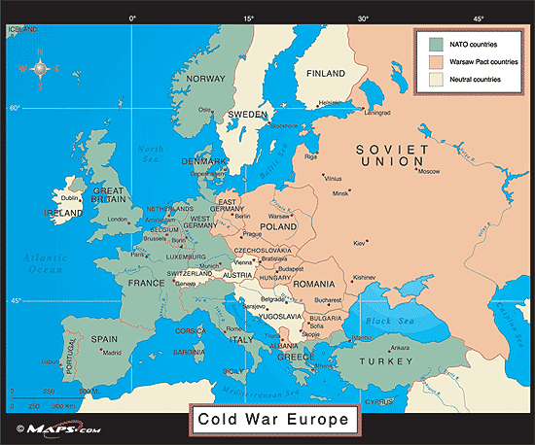
map of the alliances

Document 7:
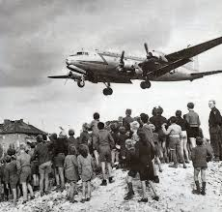
Aircrafts giving supplies during the Berlin Blockade 1949
Document 8:

Reaffirming their desire for the organisation of a system of collective security in Europe, with the participation of all the European states, irrespective of their social and state systems, which would make it possible to combine their efforts in the interests of securing peace in Europe,Taking into consideration at the same tirne the situation obtaining in Europe as the result of ratification of the Paris agreements, which provide for the formation of a new military grouping in the shape of the "Western European Union" together with a remilitarised Western Germany, and for the integration of Western Germany in the North Atlantic bloc, which increases the threat of another war and creates a menace to the national security of the peaceloving states,Convinced that, under these circumstances, the peaccloving states of Europe should take the necessary measures for safeguarding their security, and in the interests of maintaining peace in Europe,Guided by the purposes and principles of the United Nations Charter,In the interests of further strengthening and promoting friendship, co-opcration and mutual assistance, in accordance with the principles of respect for the independence and sovereignty of states, and also with the principle of noninterference in their internal affairs,Have resolved to conclude this Treaty of Friendship, Co-operation and Mutual Assistance Warsaw pact 1955
Document 9:
Rockefeller's pronouncements are an obvious example of the aggressive actions of American politicians who arc not accustomed to taking the will of the people into account.But the time when the United States diktat prevailed is over. The Soviet Union is raising its voice on behalf of, and is offering help to, the people of Cuba who are fighting for their independence. The times are not now the same as they were when only one working class-the working people of former tsarist Russia-was raising the banner of struggle, when not only economic blockade but also armed intervention was organised against us.Times are quite different now. Over 1,000 million people live in states where the working class and the working people have triumphed and where the glorious banner of Marxism-Leninism is flying. The world socialist camp is now stronger than ever before. The peoples of the socialist countries will help their Cuban brothers to uphold their independence with the object of frustrating the economic blockade the United States of America has just declared against Cuba.And not only we, the working people of the socialist camp, but the peoples of all countries must be vigilant against the intrigues of the American imperialists.It is clear to everybody that economic blockade by the American monopolists can be a prelude to intervention against Cuba. Nikita Khruschchev: Speech to the RFSR Teacher's Congress 1960

