Name___________________

Guided Reading Questions AP European History

CHAPTER 23: The Building of European Supremacy

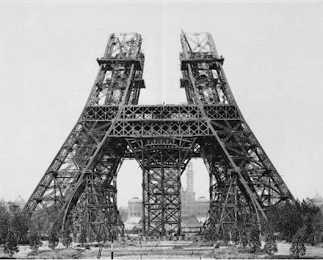
The Second Industrial Revolution (p. 762 – 765)
- How did the Second Industrial Revolution transform European society?
- What new industries developed, and which do you think had the greatest impact in the twentieth century?

Late 19th Century Urban Life (p. 768 – 772)
- Why were European cities redesigned during the late nineteenth century?
- Why were housing and health key issues for urban reform?

Varieties of late 19th Century Women’s Experiences (p. 772 – 780)
- What was the status of European women in the second half of the nineteenth century?
- Why did they grow discontented with their lot?
- What factors led to change?
- To what extent had they improved their position by 1914?
- What tactics did they use to effect change?
- Was the emancipation of women inevitable?
- How did women approach their situation differently from country to country?

Jewish Emancipation (p. 780 – 781)
- What were the major characteristics of Jewish emancipation in the nineteenth century?

Labor, Socialism, and Politics to World War I (p. 781 – 792)
- What was the status of the European working classes in 1860?
- Had it improved by 1914?
- Why did trade unions and organized mass political parties grow?
- Why were the debates over “opportunism” and “revisionism” important to the Western European socialist parties?
- What were the benefits and drawbacks of industrialization for Russia?
- Were the tsars wise to attempt to modernize their country, or should they have left it as it was?
- How did Lenin’s view of socialism differ from that of the socialists in Western Europe?

